

DRAFT
Technical Design Specification

Melbourne IT OFC
MIT Load ANZ Bank Statement Files

Author: Tony Whelan
Creation Date: 7 December 2016
Last Updated: 4 January 2017
Version: 1.0
Table of Contents

1. Requirement 3
2. Solution Overview 3
3. Outstanding Issue 3
4. Technical Objects 4
4.1 OFC Directory 4
4.2 Linux Bash Shell script 4
4.3 Sql*Loader control files 4
5. Configuration 4
5.1 Define Value Set 4
5.2 Define Value Set Values 5
5.3 Define Concurrent Executable 6
5.4 Define Concurrent Program 6
5.5 Define Request Set 8
6. Process Summary 12
7. Running program MIT Load ANZ Bank Statement Files 13
8. Running Request Set MEL IT ANZ Bank Statement Loader 13
9. DBA Deployment instructions 14

Requirement
Melbourne IT are changing banks from NAB to ANZ for OFC Payables operations. A new program and request set is required to load the ANZ Bank Statement files downloaded from the ANZ banking system, import them into the standard OFC Bank Statement tables, and run the Automatic Bank Reconciliation process.

Solution Overview

The following concurrent programs and request sets have been developed to achieve the above requirement:-
Concurrent Program: MIT Load ANZ Bank Statement Files.
Request Set: MEL IT ANZ Bank Statement Loader

Outstanding Issue

The ANZ Bank Statement files may not provide the detail required by Oracle OFC for the Auto Reconciliation process to function correctly for EFT payment batches. ANZ have advised that this is not the case, however test downloads from ANZ indicate that individual payment details for each vendor are not provided in the Statement downloads or the BAI2 downloads from the ANZ Bank site.

As a workaround for this issue, this program has been developed to load MIT ABA files into the Oracle OFC bank statement interface tables and process Auto Reconciliation using those files, after they have been uploaded successfully into the ANZ internet site as payment files.

Technical Objects

OFC Directory
A new Archive directory is required on OFC to contain bank statement files after they have been processed into the OFC tables.
/app/R12/appl/apps/apps_st/appl/MIT/12.0.0/mel/bank_stmt/Archive

Linux Bash Shell script
This script executes the Sql*loader control files to load the ANZ csv statement files into the OFC Interface tables and moves the processed files into the new Archive directory


Sql*Loader control files
2 sql*loader control files import the csv statement files into the OFC bank statement interface tables.
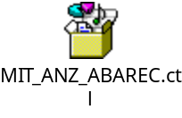

Configuration

Define Value Set
Responsibility: System Administrator
Menu Path: Application->Validation->Set
Form: Value Set
Purpose: Define a new value set.

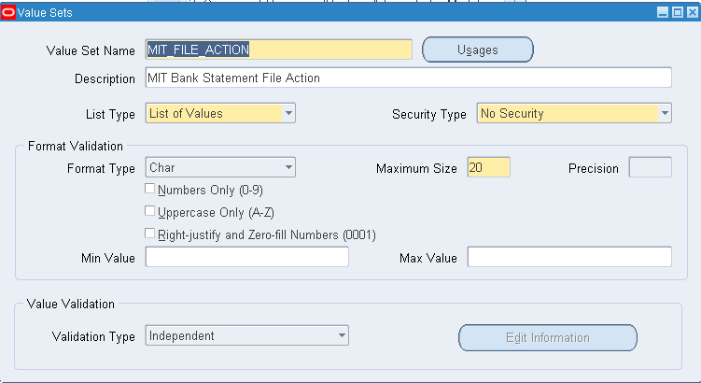

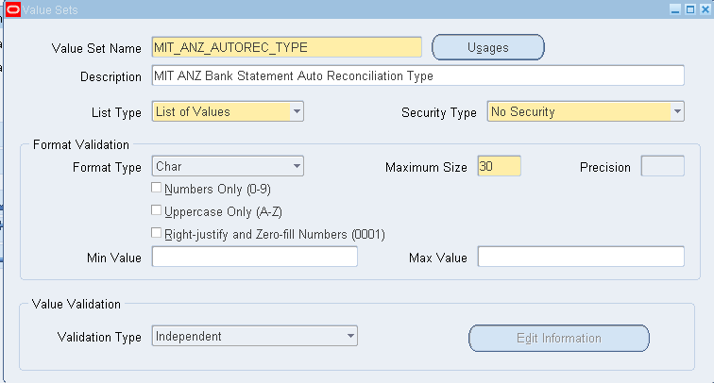

Define Value Set Values
Responsibility: System Administrator
Menu Path: Application->Validation->Values
Form: Value Set
Purpose: Define a new value set.

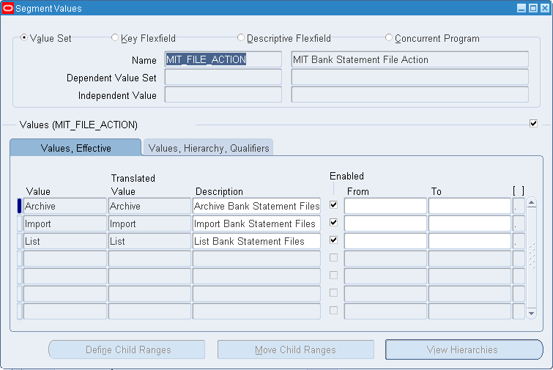

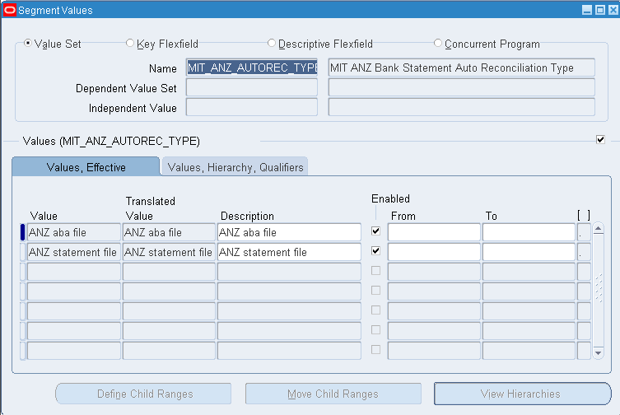

Define Concurrent Executable
Responsibility: System Administrator
Menu Path: Concurrent -> Program -> Executable
Form: Concurrent Program Executable
Purpose: Define a new concurrent program executable.

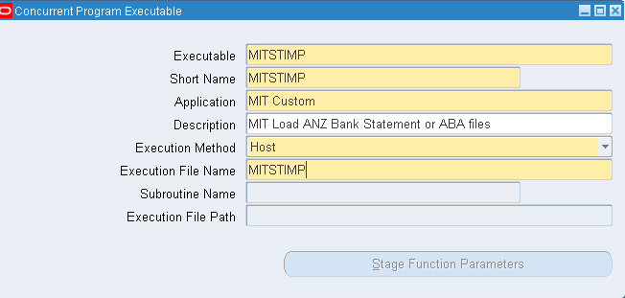

Define Concurrent Program
Responsibility: System Administrator
Menu Path: Concurrent -> Program -> Define
Form: Concurrent Program
Purpose: Define a new concurrent program.

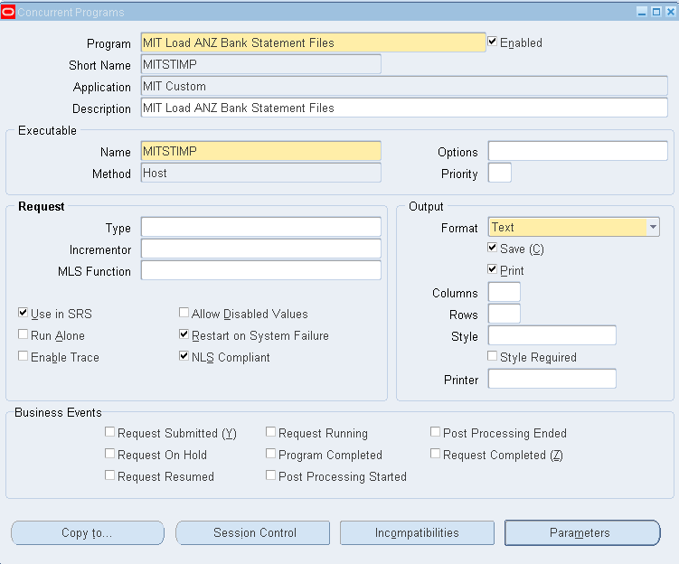

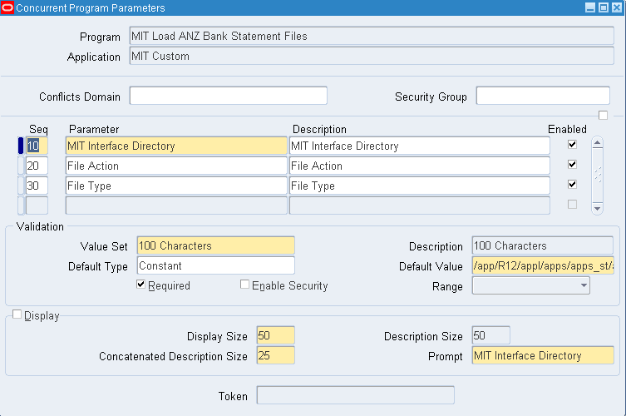

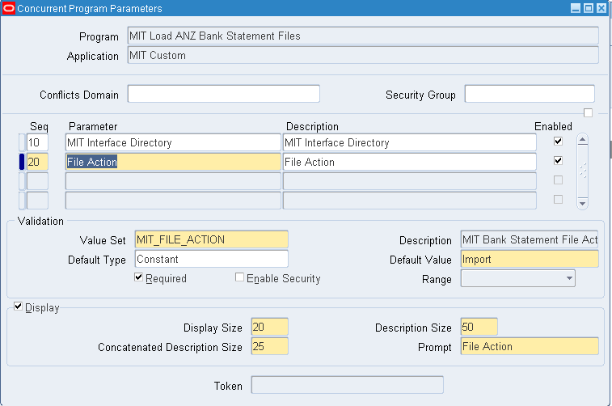

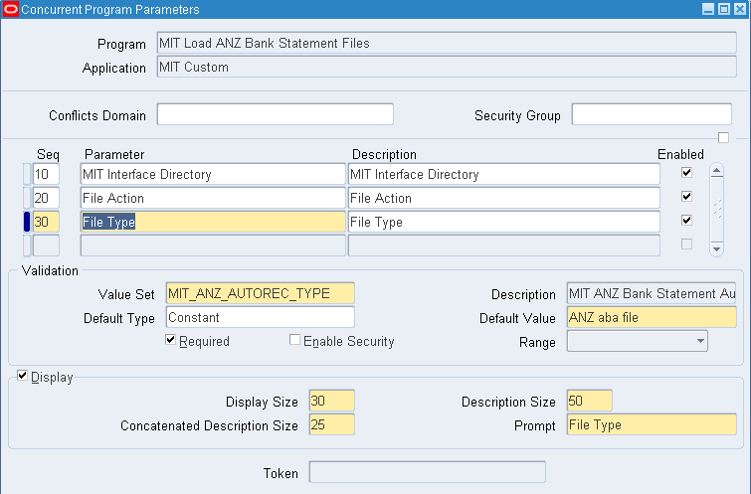

Define Request Set
Responsibility: System Administrator
Menu Path: Concurrent -> Set
Form: Request Set
Purpose: Define a new request set.

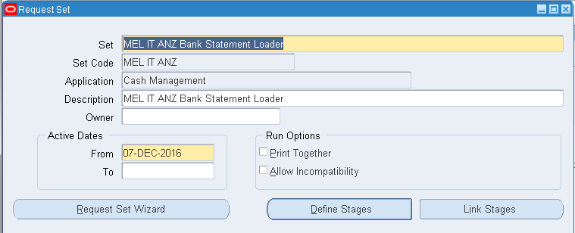

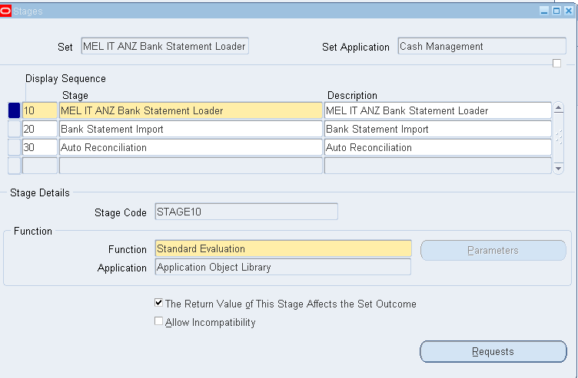

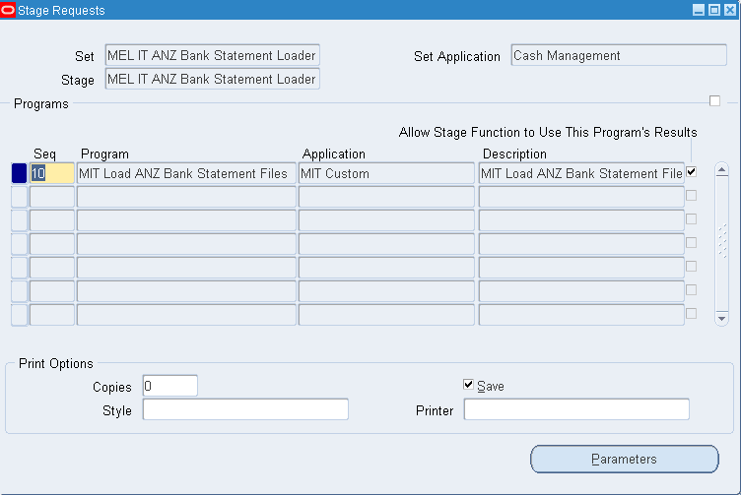

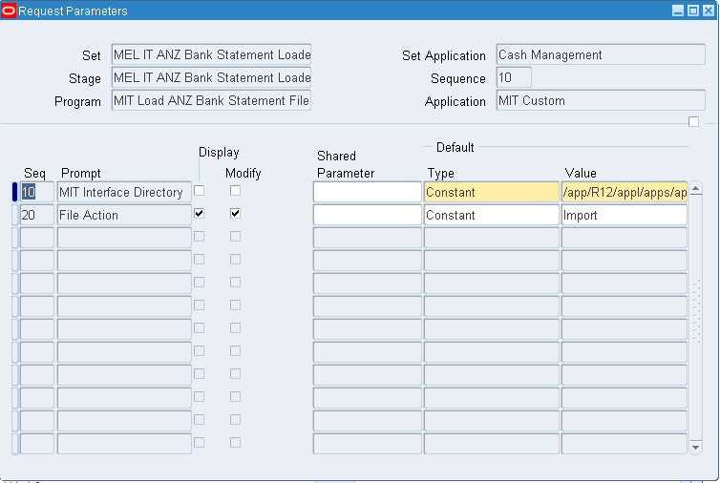

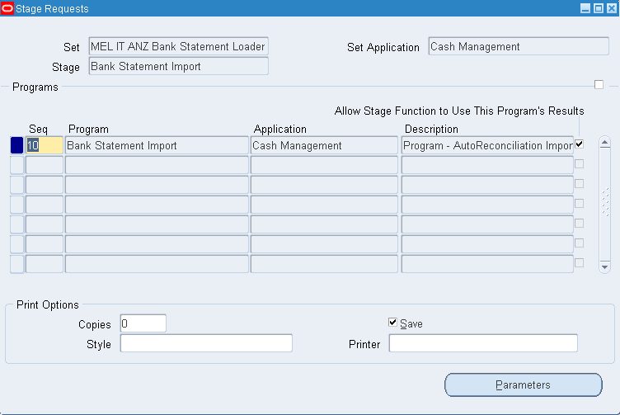

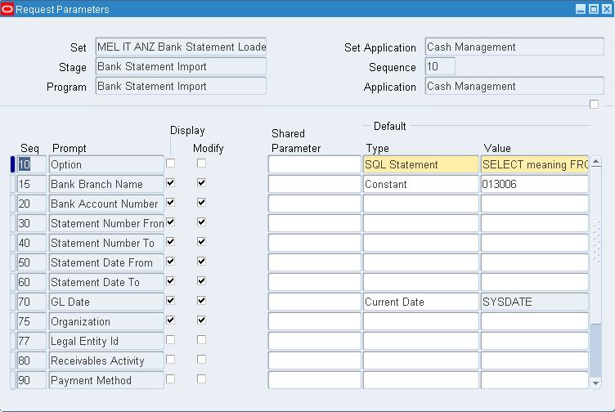

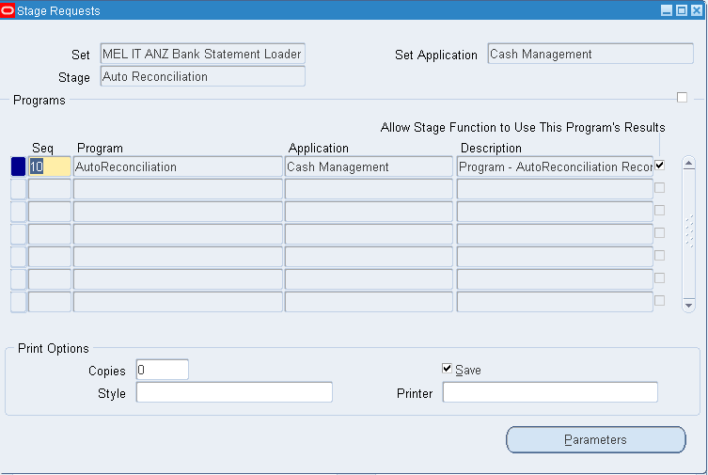

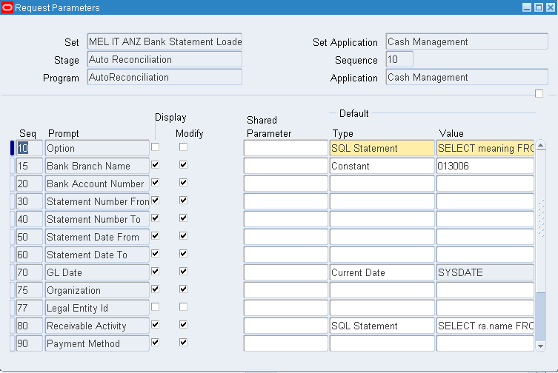

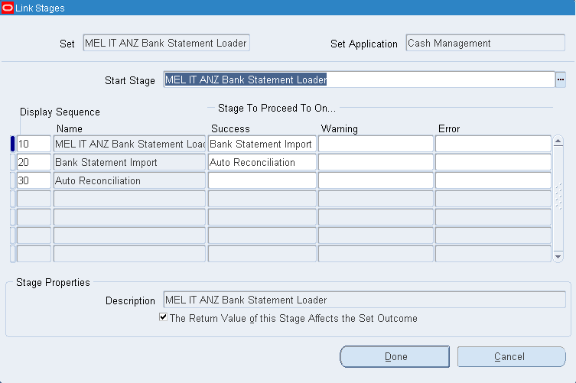

Process Summary
Seq. | Process
10 | User logins into the ANZ Banking system and executes and downloads the Bank Statement report, or alternatively use the aba payment file for the process.
20 | User copies the Bank Statement or aba file onto the nominated Samba shared directory /shared_nab/directlink/data/MELBIT01/receive/acct_info/
30 | Scheduled crap.sh bash shell script executes at 8:00 am every morning and copies the bank statement files into the OFC directory /app/R12/appl/apps/apps_st/appl/MIT/12.0.0/mel/bank_stmt/Inbound
40 | User logins to OFC Cash Management and executes the request set MEL IT ANZ Bank Statement Loader
50 | Concurrent program MIT Load ANZ Bank Statement Files validates and loads the bank statement or aba csv files into the OFC interface tables.
60 | Concurrent program Bank Statement Import validates and loads the bank statement or aba data from the OFC statement interface tables into the standard OFC statement tables
70 | Concurrent program Auto Reconciliation flags the OFC payment records and statement records as Reconciled if the payment data matches the statement data.

Running program MIT Load ANZ Bank Statement Files
The MIT Load ANZ Bank Statement Files program can be executed on its own to List, Archive or Import ANZ Bank Statement files.

- Login to your Cash Management Responsibility and execute the Concurrent Requests program.

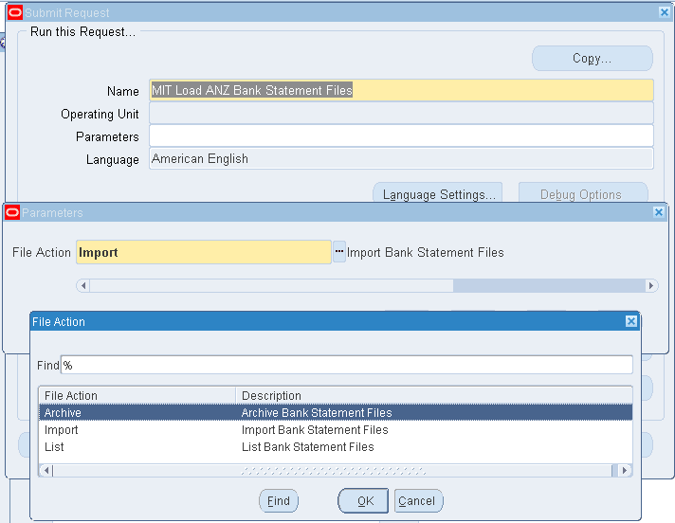

- Enter or select MIT Load ANZ Bank Statement Files.
- Select the required File Action
  - Archive: to move any files into the Archive directory that may not be required such as Log files
  - Import: to import the ANZ Bank Statement files into the OFC interface tables and move the file into the Archive directory once processed.
  - List: to list the files that are available for processing
- Select the required File Type
  - ANZ aba file: to process Auto Reconicliation using the aba file
  - ANZ statement file: to process Auto Reconicliation using the statement file
- Select OK to execute program.
- The program will list the files that are actioned in the Log file.

Running Request Set MEL IT ANZ Bank Statement Loader
This request set runs the 3 concurrent programs listed in the screen shot below.

- Login to your Cash Management Responsibility and the Concurrent Requests program and select Request Set.
- Select MEL IT ANZ Bank Statement Loader and click the Submit button.
- View the status of the jobs in the Requests View form.
- The Request Set will abort if there are any problems with the initial job.
- Review the output and log files for any issues or problems with the Bank Statement Import or the Auto Reconciliation

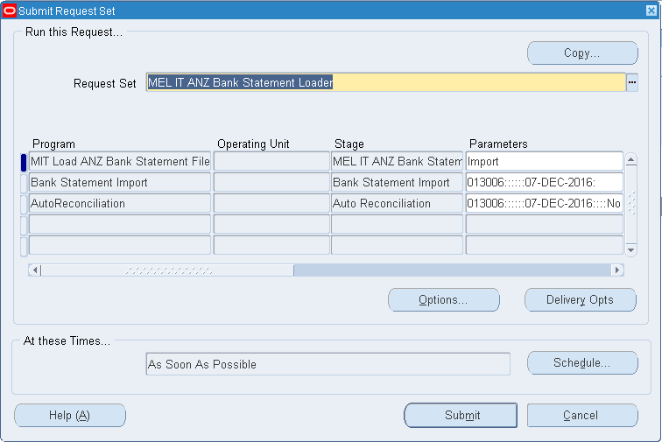

DBA Deployment instructions

- Create an Archive directory
  - Login to linux OFC production
  - cd /app/R12/appl/apps/apps_st/appl/MIT/12.0.0/mel/bank_stmt/
  - mkdir Archive

- Copy sql*loader and bash scripts into $MIT_TOP/bin
  - MITSTIMP.prog
  - MIT_ANZ_TRANSACTIONS.ctl
  - MIT_ANZ_BALANCES.ctl
  - MIT_ANZ_ABAREC.ctl

- Run the dos2unix utility on the shell script.
  - dos2unix MITSTIMP.prog

- Create a symbolic link to MITSTIMP.prog
  - ln –s $FND_TOP/bin/fndcpesr $MIT_TOP/bin/MITSTIMP
- Ensure all the OFC Bank Transaction codes are loaded from ANZTransactionCodes.dld

